**Tanh activation function**

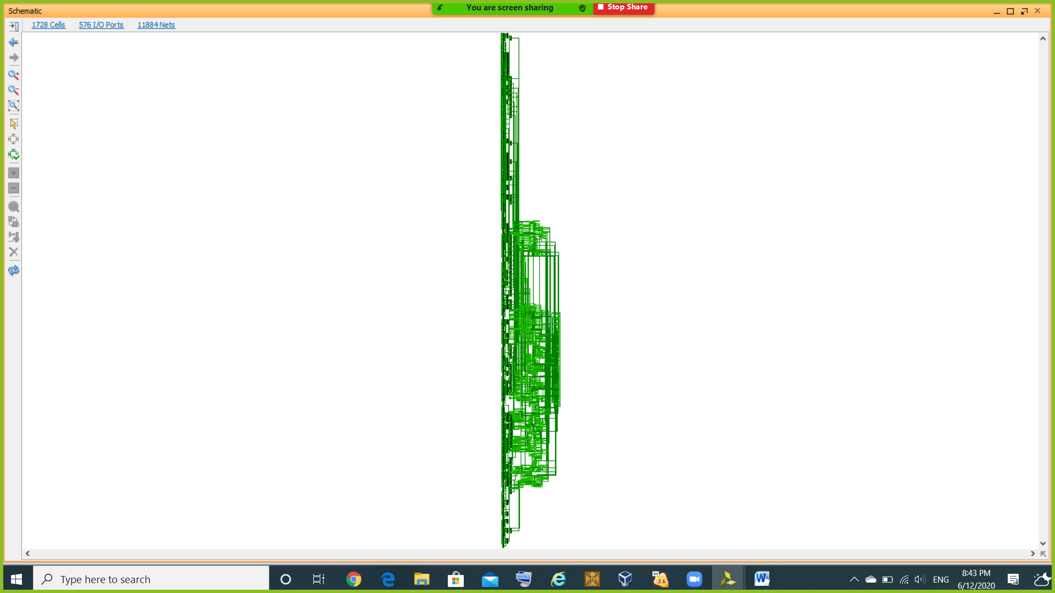

**Softmax activation function**

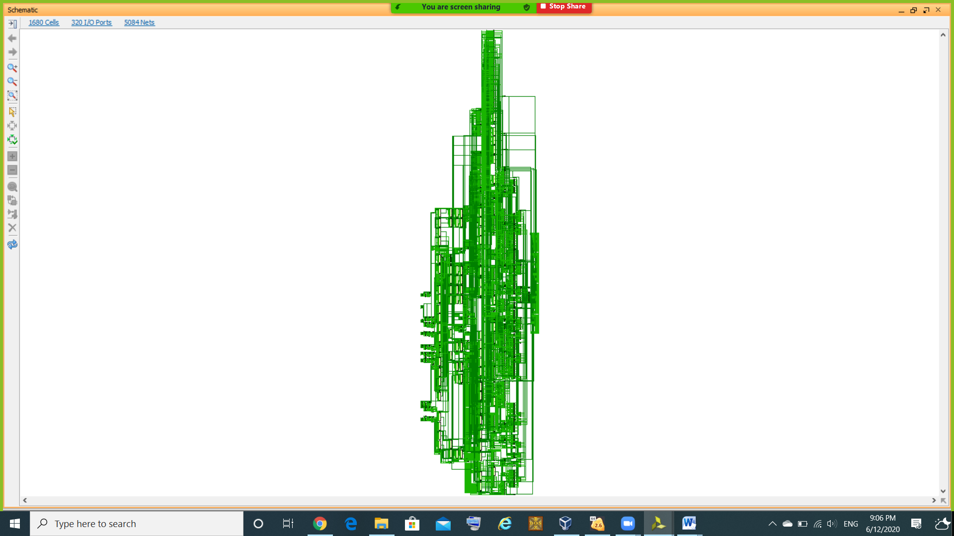

**Average pool layer**

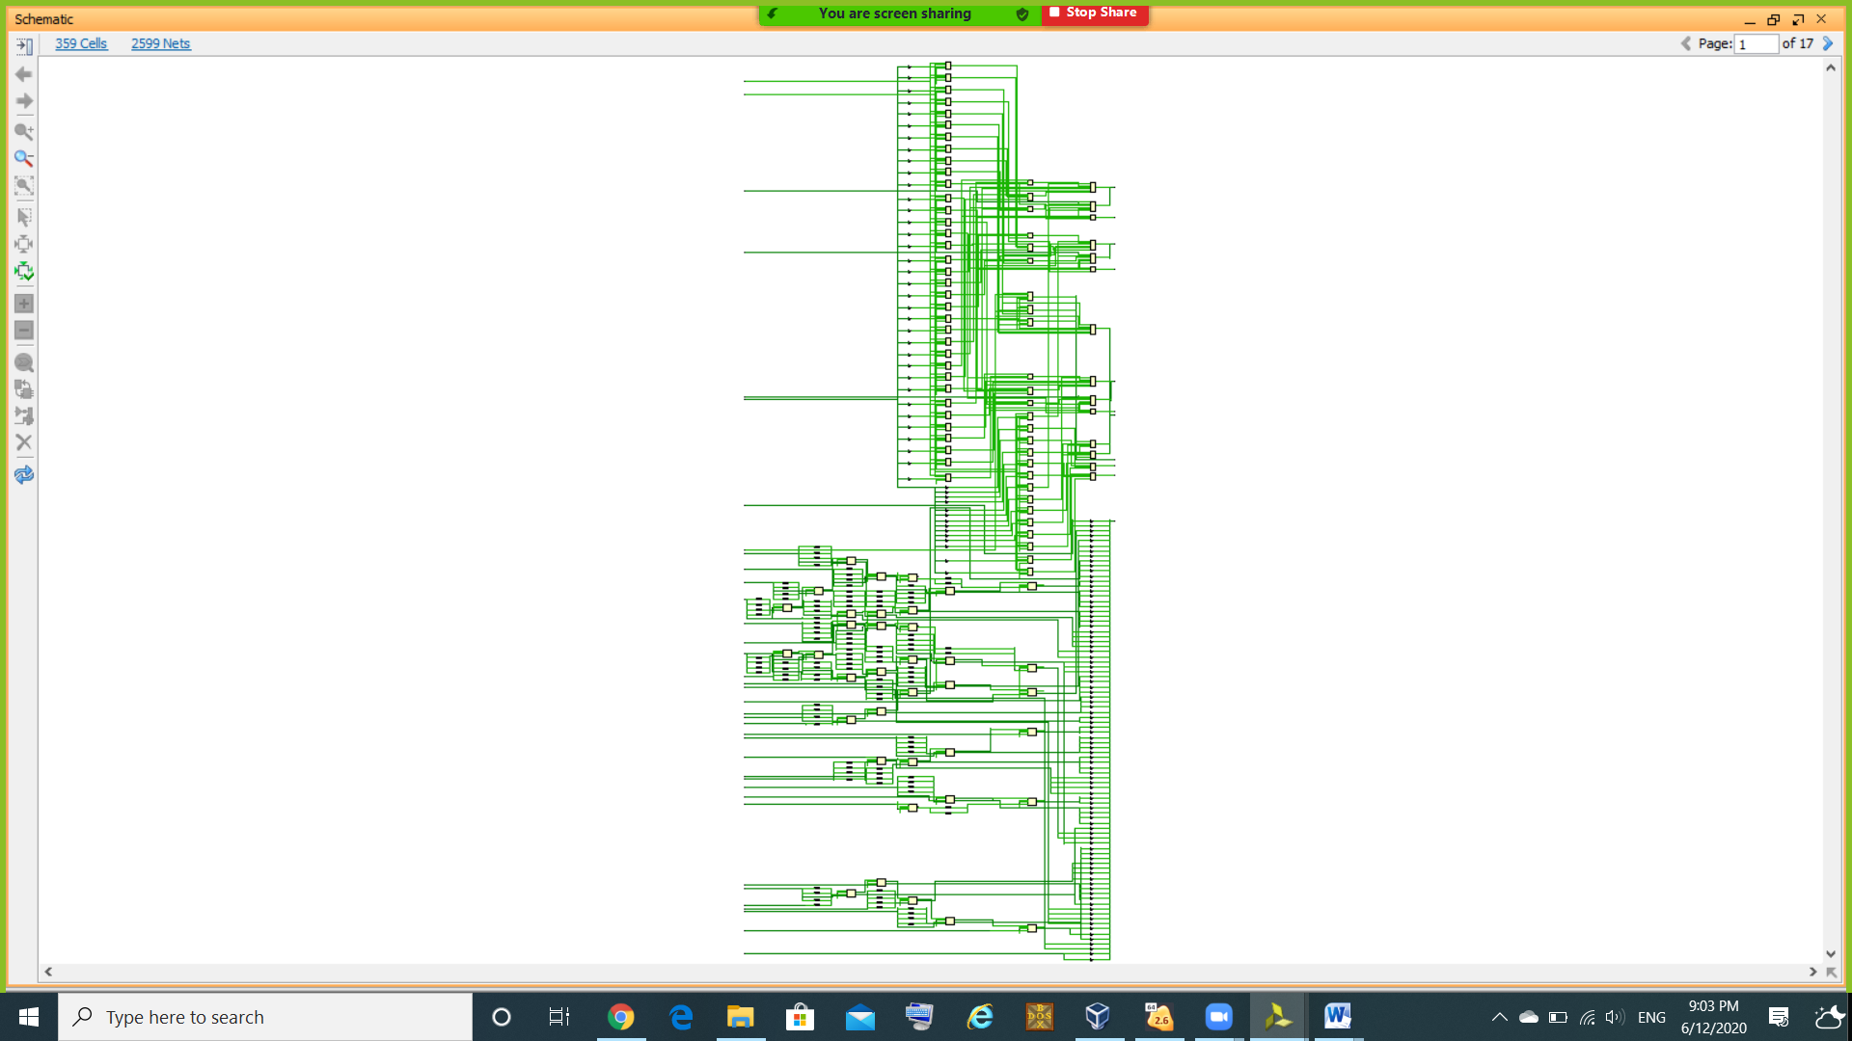

**Parallel convolution with many filters**

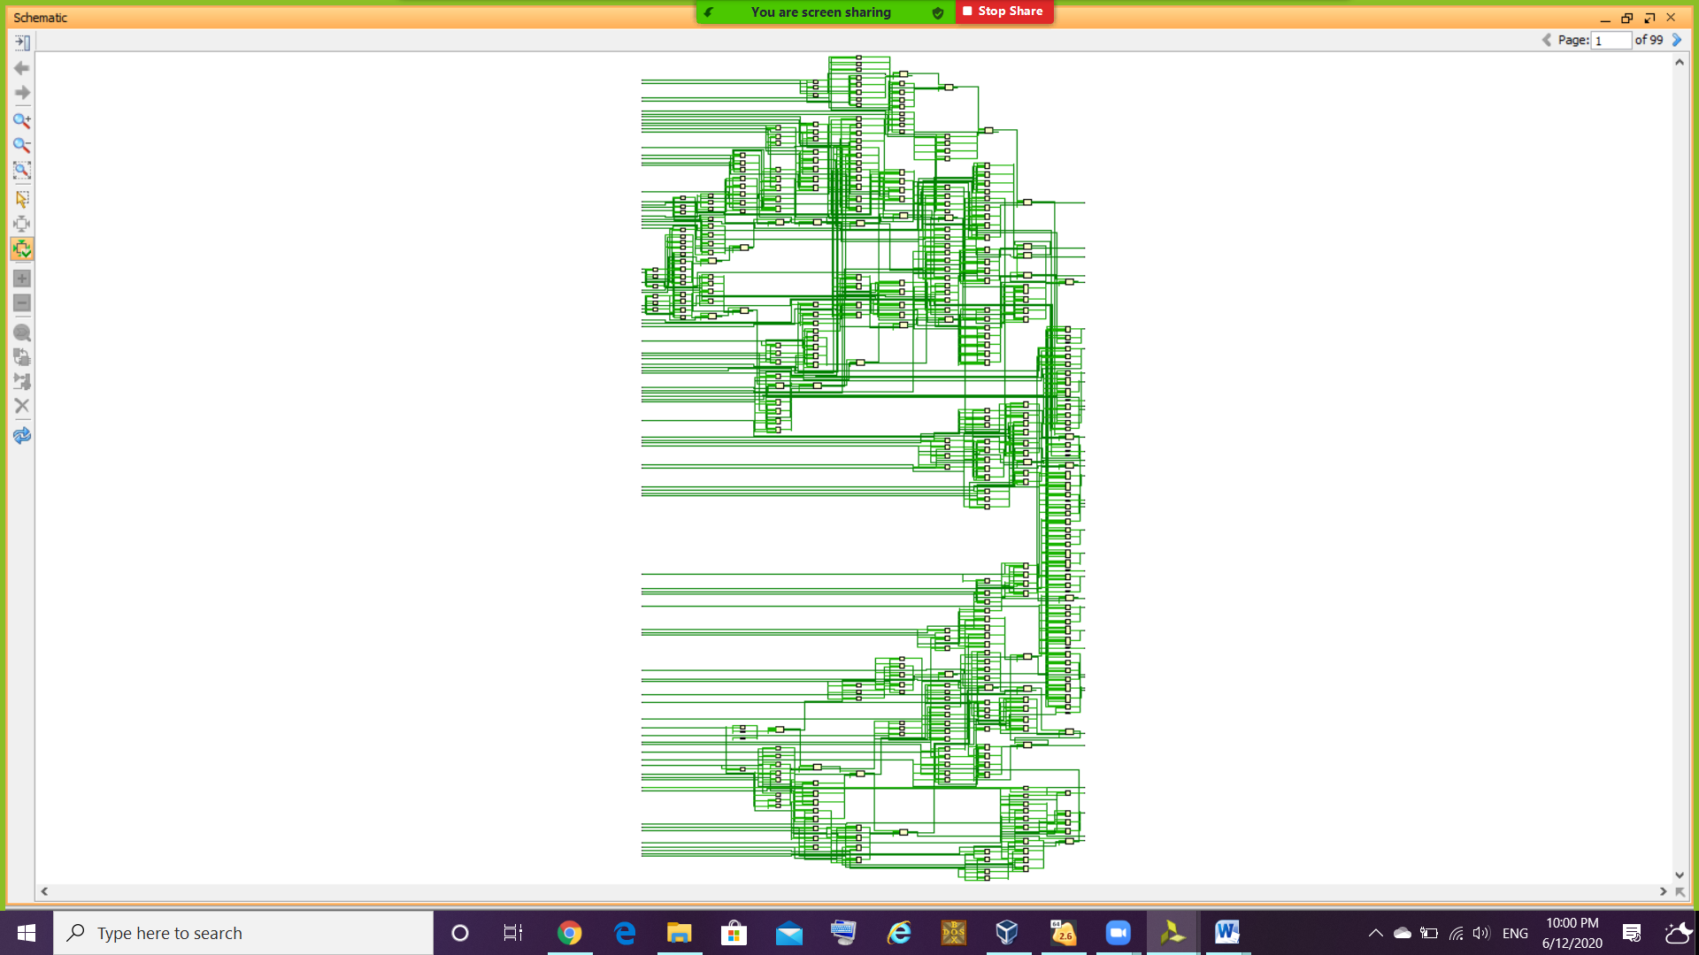

**CNN_Main (Log)**

*** Running vivado

with args -log CNN_Main.vds -m64 -mode batch -messageDb vivado.pb -notrace -source CNN_Main.tcl

WARNING: Default location for XILINX_VIVADO_HLS not found:

****** Vivado v2015.2 (64-bit)

**** SW Build 1266856 on Fri Jun 26 16:35:25 MDT 2015

**** IP Build 1264090 on Wed Jun 24 14:22:01 MDT 2015

** Copyright 1986-2015 Xilinx, Inc. All Rights Reserved.

source CNN_Main.tcl -notrace

WARNING: [Board 49-26] cannot add Board Part xilinx.com:kc705:part0:1.2 available at C:/Xilinx/Vivado/2015.2/data/boards/board_files/kc705/1.2/board.xml as part xc7k325tffg900-2 specified in board_part file is either invalid or not available

Command: synth_design -top CNN_Main -part xc7a200tfbg676-2

Starting synth_design

Attempting to get a license for feature 'Synthesis' and/or device 'xc7a200t'

INFO: [Common 17-349] Got license for feature 'Synthesis' and/or device 'xc7a200t'

---------------------------------------------------------------------------------

Starting Synthesize : Time (s): cpu = 00:00:11 ; elapsed = 00:00:18 . Memory (MB): peak = 248.258 ; gain = 75.590

---------------------------------------------------------------------------------

INFO: [Synth 8-638] synthesizing module 'CNN_Main' [C:/Users/Z50/Desktop/CUFE/Logic2/final/CNN/CNN.srcs/sources_1/imports/CNN sources/CNN_Main.v:2]

Parameter DATA_WIDTH bound to: 16 - type: integer

Parameter IMAGE_COLs bound to: 32 - type: integer

Parameter FILTER_COLs bound to: 5 - type: integer

Parameter NO_OF_FILTERs_ONE bound to: 3 - type: integer

Parameter OUTPUT_COLs_ONE bound to: 28 - type: integer

Parameter OUTPUT_COLs_TWO bound to: 14 - type: integer

Parameter NO_OF_FILTERs_TWO bound to: 3 - type: integer

Parameter OUTPUT_COLs_THREE bound to: 10 - type: integer

Parameter OUTPUT_COLs_FOUR bound to: 5 - type: integer

Parameter NO_OF_FILTERs_THREE bound to: 3 - type: integer

Parameter OUTPUT_COLs_FIVE bound to: 1 - type: integer

Parameter OUTPUT_COLs_SIX bound to: 3 - type: integer

Parameter OUTPUT_COLs_SEVEN bound to: 1 - type: integer

Parameter WEIGHTS_FILE1 bound to: C:/Users/Z50/Desktop/CUFE/Logic2/final/CNN/CNN.srcs/Weight Files/weights1.txt - type: string

Parameter WEIGHTS_FILE2 bound to: C:/Users/Z50/Desktop/CUFE/Logic2/final/CNN/CNN.srcs/Weight Files/weights2.txt - type: string

INFO: [Synth 8-638] synthesizing module 'Parallel_Convolution_with_Many_Filters' [C:/Users/Z50/Desktop/CUFE/Logic2/final/CNN/CNN.srcs/sources_1/imports/CNN sources/Parallel_Convolution_with_Many_Filters.v:2]

Parameter DATA_WIDTH bound to: 16 - type: integer

Parameter IMAGE_COLs bound to: 32 - type: integer

Parameter FILTER_COLs bound to: 5 - type: integer

Parameter NO_OF_FILTERs bound to: 3 - type: integer

Parameter OUTPUT_COLs bound to: 28 - type: integer

Parameter NO_OF_IMAGES bound to: 1 - type: integer

INFO: [Synth 8-638] synthesizing module 'Parallel_Convolution_with_Single_Filter' [C:/Users/Z50/Desktop/CUFE/Logic2/final/CNN/CNN.srcs/sources_1/imports/CNN sources/Parallel_Convolution_with_Single_Filter.v:2]

Parameter DATA_WIDTH bound to: 16 - type: integer

Parameter IMAGE_COLs bound to: 32 - type: integer

Parameter FILTER_COLs bound to: 5 - type: integer

Parameter OUTPUT_COLs bound to: 28 - type: integer

INFO: [Synth 8-638] synthesizing module 'Convolutional_Basic_Processing_Unit' [C:/Users/Z50/Desktop/CUFE/Logic2/final/CNN/CNN.srcs/sources_1/imports/CNN sources/Convolutional_Basic_Processing_Unit.v:2]

Parameter DATA_WIDTH bound to: 16 - type: integer

Parameter FILTER_COLs bound to: 5 - type: integer

INFO: [Synth 8-256] done synthesizing module 'Convolutional_Basic_Processing_Unit' (1#1) [C:/Users/Z50/Desktop/CUFE/Logic2/final/CNN/CNN.srcs/sources_1/imports/CNN sources/Convolutional_Basic_Processing_Unit.v:2]

INFO: [Synth 8-256] done synthesizing module 'Parallel_Convolution_with_Single_Filter' (2#1) [C:/Users/Z50/Desktop/CUFE/Logic2/final/CNN/CNN.srcs/sources_1/imports/CNN sources/Parallel_Convolution_with_Single_Filter.v:2]

WARNING: [Synth 8-589] replacing case/wildcard equality operator !== with logical equality operator != [C:/Users/Z50/Desktop/CUFE/Logic2/final/CNN/CNN.srcs/sources_1/imports/CNN sources/Parallel_Convolution_with_Many_Filters.v:30]

INFO: [Synth 8-256] done synthesizing module 'Parallel_Convolution_with_Many_Filters' (3#1) [C:/Users/Z50/Desktop/CUFE/Logic2/final/CNN/CNN.srcs/sources_1/imports/CNN sources/Parallel_Convolution_with_Many_Filters.v:2]

INFO: [Synth 8-638] synthesizing module 'Tanh_activation_Function' [C:/Users/Z50/Desktop/CUFE/Logic2/final/CNN/CNN.srcs/sources_1/imports/CNN sources/Tanh_activation_Function.v:3]

Parameter DATA_WIDTH bound to: 16 - type: integer

Parameter NO_OF_FILTERs bound to: 3 - type: integer

Parameter OUTPUT_COLs bound to: 28 - type: integer

INFO: [Synth 8-256] done synthesizing module 'Tanh_activation_Function' (4#1) [C:/Users/Z50/Desktop/CUFE/Logic2/final/CNN/CNN.srcs/sources_1/imports/CNN sources/Tanh_activation_Function.v:3]

INFO: [Synth 8-638] synthesizing module 'Average_pool_layer' [C:/Users/Z50/Desktop/CUFE/Logic2/final/CNN/CNN.srcs/sources_1/imports/CNN sources/Average_pool_layer.v:3]

Parameter DATA_WIDTH bound to: 16 - type: integer

Parameter IMAGE_COLs bound to: 28 - type: integer

Parameter NO_OF_IMAGES bound to: 3 - type: integer

Parameter OUTPUT_COLs bound to: 14 - type: integer

INFO: [Synth 8-638] synthesizing module 'Average_pool_layer_Single_image' [C:/Users/Z50/Desktop/CUFE/Logic2/final/CNN/CNN.srcs/sources_1/imports/CNN sources/Average_pool_layer_Single_image.v:3]

Parameter DATA_WIDTH bound to: 16 - type: integer

Parameter IMAGE_COLs bound to: 28 - type: integer

Parameter OUTPUT_COLs bound to: 14 - type: integer

INFO: [Synth 8-638] synthesizing module 'fp_avg' [C:/Users/Z50/Desktop/CUFE/Logic2/final/CNN/CNN.srcs/sources_1/imports/CNN sources/fp_avg.v:2]

Parameter DATA_WIDTH bound to: 16 - type: integer

INFO: [Synth 8-256] done synthesizing module 'fp_avg' (5#1) [C:/Users/Z50/Desktop/CUFE/Logic2/final/CNN/CNN.srcs/sources_1/imports/CNN sources/fp_avg.v:2]

INFO: [Synth 8-256] done synthesizing module 'Average_pool_layer_Single_image' (6#1) [C:/Users/Z50/Desktop/CUFE/Logic2/final/CNN/CNN.srcs/sources_1/imports/CNN sources/Average_pool_layer_Single_image.v:3]

INFO: [Synth 8-256] done synthesizing module 'Average_pool_layer' (7#1) [C:/Users/Z50/Desktop/CUFE/Logic2/final/CNN/CNN.srcs/sources_1/imports/CNN sources/Average_pool_layer.v:3]

INFO: [Synth 8-638] synthesizing module 'Tanh_activation_Function__parameterized0' [C:/Users/Z50/Desktop/CUFE/Logic2/final/CNN/CNN.srcs/sources_1/imports/CNN sources/Tanh_activation_Function.v:3]

Parameter DATA_WIDTH bound to: 16 - type: integer

Parameter NO_OF_FILTERs bound to: 3 - type: integer

Parameter OUTPUT_COLs bound to: 14 - type: integer

INFO: [Synth 8-256] done synthesizing module 'Tanh_activation_Function__parameterized0' (7#1) [C:/Users/Z50/Desktop/CUFE/Logic2/final/CNN/CNN.srcs/sources_1/imports/CNN sources/Tanh_activation_Function.v:3]

INFO: [Synth 8-638] synthesizing module 'Parallel_Convolution_with_Many_Filters__parameterized0' [C:/Users/Z50/Desktop/CUFE/Logic2/final/CNN/CNN.srcs/sources_1/imports/CNN sources/Parallel_Convolution_with_Many_Filters.v:2]

Parameter DATA_WIDTH bound to: 16 - type: integer

Parameter IMAGE_COLs bound to: 14 - type: integer

Parameter FILTER_COLs bound to: 5 - type: integer

Parameter NO_OF_FILTERs bound to: 3 - type: integer

Parameter OUTPUT_COLs bound to: 10 - type: integer

Parameter NO_OF_IMAGES bound to: 3 - type: integer

INFO: [Synth 8-638] synthesizing module 'Parallel_Convolution_with_Single_Filter__parameterized0' [C:/Users/Z50/Desktop/CUFE/Logic2/final/CNN/CNN.srcs/sources_1/imports/CNN sources/Parallel_Convolution_with_Single_Filter.v:2]

Parameter DATA_WIDTH bound to: 16 - type: integer

Parameter IMAGE_COLs bound to: 14 - type: integer

Parameter FILTER_COLs bound to: 5 - type: integer

Parameter OUTPUT_COLs bound to: 10 - type: integer

INFO: [Synth 8-256] done synthesizing module 'Parallel_Convolution_with_Single_Filter__parameterized0' (7#1) [C:/Users/Z50/Desktop/CUFE/Logic2/final/CNN/CNN.srcs/sources_1/imports/CNN sources/Parallel_Convolution_with_Single_Filter.v:2]

INFO: [Synth 8-638] synthesizing module 'Parallel_Convolution_with_Single_Filter__parameterized1' [C:/Users/Z50/Desktop/CUFE/Logic2/final/CNN/CNN.srcs/sources_1/imports/CNN sources/Parallel_Convolution_with_Single_Filter.v:2]

Parameter DATA_WIDTH bound to: 16 - type: integer

Parameter IMAGE_COLs bound to: 14 - type: integer

Parameter FILTER_COLs bound to: 5 - type: integer

Parameter OUTPUT_COLs bound to: 10 - type: integer

INFO: [Synth 8-256] done synthesizing module 'Parallel_Convolution_with_Single_Filter__parameterized1' (7#1) [C:/Users/Z50/Desktop/CUFE/Logic2/final/CNN/CNN.srcs/sources_1/imports/CNN sources/Parallel_Convolution_with_Single_Filter.v:2]

INFO: [Synth 8-638] synthesizing module 'Parallel_Convolution_with_Single_Filter__parameterized2' [C:/Users/Z50/Desktop/CUFE/Logic2/final/CNN/CNN.srcs/sources_1/imports/CNN sources/Parallel_Convolution_with_Single_Filter.v:2]

Parameter DATA_WIDTH bound to: 16 - type: integer

Parameter IMAGE_COLs bound to: 14 - type: integer

Parameter FILTER_COLs bound to: 5 - type: integer

Parameter OUTPUT_COLs bound to: 10 - type: integer

INFO: [Synth 8-256] done synthesizing module 'Parallel_Convolution_with_Single_Filter__parameterized2' (7#1) [C:/Users/Z50/Desktop/CUFE/Logic2/final/CNN/CNN.srcs/sources_1/imports/CNN sources/Parallel_Convolution_with_Single_Filter.v:2]

WARNING: [Synth 8-589] replacing case/wildcard equality operator !== with logical equality operator != [C:/Users/Z50/Desktop/CUFE/Logic2/final/CNN/CNN.srcs/sources_1/imports/CNN sources/Parallel_Convolution_with_Many_Filters.v:30]

INFO: [Synth 8-256] done synthesizing module 'Parallel_Convolution_with_Many_Filters__parameterized0' (7#1) [C:/Users/Z50/Desktop/CUFE/Logic2/final/CNN/CNN.srcs/sources_1/imports/CNN sources/Parallel_Convolution_with_Many_Filters.v:2]

INFO: [Synth 8-638] synthesizing module 'Tanh_activation_Function__parameterized1' [C:/Users/Z50/Desktop/CUFE/Logic2/final/CNN/CNN.srcs/sources_1/imports/CNN sources/Tanh_activation_Function.v:3]

Parameter DATA_WIDTH bound to: 16 - type: integer

Parameter NO_OF_FILTERs bound to: 3 - type: integer

Parameter OUTPUT_COLs bound to: 10 - type: integer

INFO: [Synth 8-256] done synthesizing module 'Tanh_activation_Function__parameterized1' (7#1) [C:/Users/Z50/Desktop/CUFE/Logic2/final/CNN/CNN.srcs/sources_1/imports/CNN sources/Tanh_activation_Function.v:3]

INFO: [Synth 8-638] synthesizing module 'Average_pool_layer__parameterized0' [C:/Users/Z50/Desktop/CUFE/Logic2/final/CNN/CNN.srcs/sources_1/imports/CNN sources/Average_pool_layer.v:3]

Parameter DATA_WIDTH bound to: 16 - type: integer

Parameter IMAGE_COLs bound to: 10 - type: integer

Parameter NO_OF_IMAGES bound to: 3 - type: integer

Parameter OUTPUT_COLs bound to: 5 - type: integer

INFO: [Synth 8-638] synthesizing module 'Average_pool_layer_Single_image__parameterized0' [C:/Users/Z50/Desktop/CUFE/Logic2/final/CNN/CNN.srcs/sources_1/imports/CNN sources/Average_pool_layer_Single_image.v:3]

Parameter DATA_WIDTH bound to: 16 - type: integer

Parameter IMAGE_COLs bound to: 10 - type: integer

Parameter OUTPUT_COLs bound to: 5 - type: integer

INFO: [Synth 8-256] done synthesizing module 'Average_pool_layer_Single_image__parameterized0' (7#1) [C:/Users/Z50/Desktop/CUFE/Logic2/final/CNN/CNN.srcs/sources_1/imports/CNN sources/Average_pool_layer_Single_image.v:3]

INFO: [Synth 8-638] synthesizing module 'Average_pool_layer_Single_image__parameterized1' [C:/Users/Z50/Desktop/CUFE/Logic2/final/CNN/CNN.srcs/sources_1/imports/CNN sources/Average_pool_layer_Single_image.v:3]

Parameter DATA_WIDTH bound to: 16 - type: integer

Parameter IMAGE_COLs bound to: 10 - type: integer

Parameter OUTPUT_COLs bound to: 5 - type: integer

INFO: [Synth 8-256] done synthesizing module 'Average_pool_layer_Single_image__parameterized1' (7#1) [C:/Users/Z50/Desktop/CUFE/Logic2/final/CNN/CNN.srcs/sources_1/imports/CNN sources/Average_pool_layer_Single_image.v:3]

INFO: [Synth 8-638] synthesizing module 'Average_pool_layer_Single_image__parameterized2' [C:/Users/Z50/Desktop/CUFE/Logic2/final/CNN/CNN.srcs/sources_1/imports/CNN sources/Average_pool_layer_Single_image.v:3]

Parameter DATA_WIDTH bound to: 16 - type: integer

Parameter IMAGE_COLs bound to: 10 - type: integer

Parameter OUTPUT_COLs bound to: 5 - type: integer

INFO: [Synth 8-256] done synthesizing module 'Average_pool_layer_Single_image__parameterized2' (7#1) [C:/Users/Z50/Desktop/CUFE/Logic2/final/CNN/CNN.srcs/sources_1/imports/CNN sources/Average_pool_layer_Single_image.v:3]

INFO: [Synth 8-256] done synthesizing module 'Average_pool_layer__parameterized0' (7#1) [C:/Users/Z50/Desktop/CUFE/Logic2/final/CNN/CNN.srcs/sources_1/imports/CNN sources/Average_pool_layer.v:3]

INFO: [Synth 8-638] synthesizing module 'Tanh_activation_Function__parameterized2' [C:/Users/Z50/Desktop/CUFE/Logic2/final/CNN/CNN.srcs/sources_1/imports/CNN sources/Tanh_activation_Function.v:3]

Parameter DATA_WIDTH bound to: 16 - type: integer

Parameter NO_OF_FILTERs bound to: 3 - type: integer

Parameter OUTPUT_COLs bound to: 5 - type: integer

INFO: [Synth 8-256] done synthesizing module 'Tanh_activation_Function__parameterized2' (7#1) [C:/Users/Z50/Desktop/CUFE/Logic2/final/CNN/CNN.srcs/sources_1/imports/CNN sources/Tanh_activation_Function.v:3]

INFO: [Synth 8-638] synthesizing module 'Parallel_Convolution_with_Many_Filters__parameterized1' [C:/Users/Z50/Desktop/CUFE/Logic2/final/CNN/CNN.srcs/sources_1/imports/CNN sources/Parallel_Convolution_with_Many_Filters.v:2]

Parameter DATA_WIDTH bound to: 16 - type: integer

Parameter IMAGE_COLs bound to: 5 - type: integer

Parameter FILTER_COLs bound to: 5 - type: integer

Parameter NO_OF_FILTERs bound to: 3 - type: integer

Parameter OUTPUT_COLs bound to: 1 - type: integer

Parameter NO_OF_IMAGES bound to: 3 - type: integer

INFO: [Synth 8-638] synthesizing module 'Parallel_Convolution_with_Single_Filter__parameterized3' [C:/Users/Z50/Desktop/CUFE/Logic2/final/CNN/CNN.srcs/sources_1/imports/CNN sources/Parallel_Convolution_with_Single_Filter.v:2]

Parameter DATA_WIDTH bound to: 16 - type: integer

Parameter IMAGE_COLs bound to: 5 - type: integer

Parameter FILTER_COLs bound to: 5 - type: integer

Parameter OUTPUT_COLs bound to: 1 - type: integer

INFO: [Synth 8-256] done synthesizing module 'Parallel_Convolution_with_Single_Filter__parameterized3' (7#1) [C:/Users/Z50/Desktop/CUFE/Logic2/final/CNN/CNN.srcs/sources_1/imports/CNN sources/Parallel_Convolution_with_Single_Filter.v:2]

INFO: [Synth 8-638] synthesizing module 'Parallel_Convolution_with_Single_Filter__parameterized4' [C:/Users/Z50/Desktop/CUFE/Logic2/final/CNN/CNN.srcs/sources_1/imports/CNN sources/Parallel_Convolution_with_Single_Filter.v:2]

Parameter DATA_WIDTH bound to: 16 - type: integer

Parameter IMAGE_COLs bound to: 5 - type: integer

Parameter FILTER_COLs bound to: 5 - type: integer

Parameter OUTPUT_COLs bound to: 1 - type: integer

INFO: [Synth 8-256] done synthesizing module 'Parallel_Convolution_with_Single_Filter__parameterized4' (7#1) [C:/Users/Z50/Desktop/CUFE/Logic2/final/CNN/CNN.srcs/sources_1/imports/CNN sources/Parallel_Convolution_with_Single_Filter.v:2]

INFO: [Synth 8-638] synthesizing module 'Parallel_Convolution_with_Single_Filter__parameterized5' [C:/Users/Z50/Desktop/CUFE/Logic2/final/CNN/CNN.srcs/sources_1/imports/CNN sources/Parallel_Convolution_with_Single_Filter.v:2]

Parameter DATA_WIDTH bound to: 16 - type: integer

Parameter IMAGE_COLs bound to: 5 - type: integer

Parameter FILTER_COLs bound to: 5 - type: integer

Parameter OUTPUT_COLs bound to: 1 - type: integer

INFO: [Synth 8-256] done synthesizing module 'Parallel_Convolution_with_Single_Filter__parameterized5' (7#1) [C:/Users/Z50/Desktop/CUFE/Logic2/final/CNN/CNN.srcs/sources_1/imports/CNN sources/Parallel_Convolution_with_Single_Filter.v:2]

WARNING: [Synth 8-589] replacing case/wildcard equality operator !== with logical equality operator != [C:/Users/Z50/Desktop/CUFE/Logic2/final/CNN/CNN.srcs/sources_1/imports/CNN sources/Parallel_Convolution_with_Many_Filters.v:30]

INFO: [Synth 8-256] done synthesizing module 'Parallel_Convolution_with_Many_Filters__parameterized1' (7#1) [C:/Users/Z50/Desktop/CUFE/Logic2/final/CNN/CNN.srcs/sources_1/imports/CNN sources/Parallel_Convolution_with_Many_Filters.v:2]

INFO: [Synth 8-638] synthesizing module 'Tanh_activation_Function__parameterized3' [C:/Users/Z50/Desktop/CUFE/Logic2/final/CNN/CNN.srcs/sources_1/imports/CNN sources/Tanh_activation_Function.v:3]

Parameter DATA_WIDTH bound to: 16 - type: integer

Parameter NO_OF_FILTERs bound to: 3 - type: integer

Parameter OUTPUT_COLs bound to: 1 - type: integer

INFO: [Synth 8-256] done synthesizing module 'Tanh_activation_Function__parameterized3' (7#1) [C:/Users/Z50/Desktop/CUFE/Logic2/final/CNN/CNN.srcs/sources_1/imports/CNN sources/Tanh_activation_Function.v:3]

INFO: [Synth 8-638] synthesizing module 'Parallel_2D_multiplier' [C:/Users/Z50/Desktop/CUFE/Logic2/final/CNN/CNN.srcs/sources_1/imports/CNN sources/Parallel_2D_multiplier.v:2]

Parameter DATA_WIDTH bound to: 16 - type: integer

Parameter Parallel_PEs_ROW bound to: 3 - type: integer

Parameter Parallel_PEs_COL bound to: 3 - type: integer

Parameter file bound to: C:/Users/Z50/Desktop/CUFE/Logic2/final/CNN/CNN.srcs/Weight Files/weights1.txt - type: string

INFO: [Synth 8-638] synthesizing module 'weights_Memory' [C:/Users/Z50/Desktop/CUFE/Logic2/final/CNN/CNN.srcs/sources_1/imports/CNN sources/weights_Memory.v:1]

Parameter DATA_WIDTH bound to: 16 - type: integer

Parameter ADDR_WIDTH bound to: 9 - type: integer

Parameter parallel_fc_PE bound to: 3 - type: integer

Parameter fc_columns bound to: 3 - type: integer

Parameter tot_weight_size bound to: 9 - type: integer

Parameter file bound to: C:/Users/Z50/Desktop/CUFE/Logic2/final/CNN/CNN.srcs/Weight Files/weights1.txt - type: string

INFO: [Synth 8-3876] $readmem data file 'C:/Users/Z50/Desktop/CUFE/Logic2/final/CNN/CNN.srcs/Weight Files/weights1.txt' is read successfully [C:/Users/Z50/Desktop/CUFE/Logic2/final/CNN/CNN.srcs/sources_1/imports/CNN sources/weights_Memory.v:29]

INFO: [Synth 8-256] done synthesizing module 'weights_Memory' (8#1) [C:/Users/Z50/Desktop/CUFE/Logic2/final/CNN/CNN.srcs/sources_1/imports/CNN sources/weights_Memory.v:1]

INFO: [Synth 8-638] synthesizing module 'FC_Layer_ANN' [C:/Users/Z50/Desktop/CUFE/Logic2/final/CNN/CNN.srcs/sources_1/imports/CNN sources/FC_LAYER_ANN.v:2]

Parameter DATA_WIDTH bound to: 16 - type: integer

Parameter parallel_fc_PE bound to: 3 - type: integer

INFO: [Synth 8-638] synthesizing module 'PE_FC_ANN' [C:/Users/Z50/Desktop/CUFE/Logic2/final/CNN/CNN.srcs/sources_1/imports/CNN sources/PE_FC_ANN.v:2]

Parameter DATA_WIDTH bound to: 16 - type: integer

INFO: [Synth 8-256] done synthesizing module 'PE_FC_ANN' (9#1) [C:/Users/Z50/Desktop/CUFE/Logic2/final/CNN/CNN.srcs/sources_1/imports/CNN sources/PE_FC_ANN.v:2]

INFO: [Synth 8-256] done synthesizing module 'FC_Layer_ANN' (10#1) [C:/Users/Z50/Desktop/CUFE/Logic2/final/CNN/CNN.srcs/sources_1/imports/CNN sources/FC_LAYER_ANN.v:2]

INFO: [Synth 8-256] done synthesizing module 'Parallel_2D_multiplier' (11#1) [C:/Users/Z50/Desktop/CUFE/Logic2/final/CNN/CNN.srcs/sources_1/imports/CNN sources/Parallel_2D_multiplier.v:2]

INFO: [Synth 8-638] synthesizing module 'Tanh_activation_Function__parameterized4' [C:/Users/Z50/Desktop/CUFE/Logic2/final/CNN/CNN.srcs/sources_1/imports/CNN sources/Tanh_activation_Function.v:3]

Parameter DATA_WIDTH bound to: 16 - type: integer

Parameter NO_OF_FILTERs bound to: 3 - type: integer

Parameter OUTPUT_COLs bound to: 1 - type: integer

INFO: [Synth 8-256] done synthesizing module 'Tanh_activation_Function__parameterized4' (11#1) [C:/Users/Z50/Desktop/CUFE/Logic2/final/CNN/CNN.srcs/sources_1/imports/CNN sources/Tanh_activation_Function.v:3]

INFO: [Synth 8-638] synthesizing module 'Parallel_2D_multiplier__parameterized0' [C:/Users/Z50/Desktop/CUFE/Logic2/final/CNN/CNN.srcs/sources_1/imports/CNN sources/Parallel_2D_multiplier.v:2]

Parameter DATA_WIDTH bound to: 16 - type: integer

Parameter Parallel_PEs_ROW bound to: 3 - type: integer

Parameter Parallel_PEs_COL bound to: 1 - type: integer

Parameter file bound to: C:/Users/Z50/Desktop/CUFE/Logic2/final/CNN/CNN.srcs/Weight Files/weights2.txt - type: string

INFO: [Synth 8-638] synthesizing module 'weights_Memory__parameterized0' [C:/Users/Z50/Desktop/CUFE/Logic2/final/CNN/CNN.srcs/sources_1/imports/CNN sources/weights_Memory.v:1]

Parameter DATA_WIDTH bound to: 16 - type: integer

Parameter ADDR_WIDTH bound to: 9 - type: integer

Parameter parallel_fc_PE bound to: 3 - type: integer

Parameter fc_columns bound to: 1 - type: integer

Parameter tot_weight_size bound to: 3 - type: integer

Parameter file bound to: C:/Users/Z50/Desktop/CUFE/Logic2/final/CNN/CNN.srcs/Weight Files/weights2.txt - type: string

INFO: [Synth 8-3876] $readmem data file 'C:/Users/Z50/Desktop/CUFE/Logic2/final/CNN/CNN.srcs/Weight Files/weights2.txt' is read successfully [C:/Users/Z50/Desktop/CUFE/Logic2/final/CNN/CNN.srcs/sources_1/imports/CNN sources/weights_Memory.v:29]

INFO: [Synth 8-256] done synthesizing module 'weights_Memory__parameterized0' (11#1) [C:/Users/Z50/Desktop/CUFE/Logic2/final/CNN/CNN.srcs/sources_1/imports/CNN sources/weights_Memory.v:1]

INFO: [Synth 8-638] synthesizing module 'FC_Layer_ANN__parameterized0' [C:/Users/Z50/Desktop/CUFE/Logic2/final/CNN/CNN.srcs/sources_1/imports/CNN sources/FC_LAYER_ANN.v:2]

Parameter DATA_WIDTH bound to: 16 - type: integer

Parameter parallel_fc_PE bound to: 1 - type: integer

INFO: [Synth 8-256] done synthesizing module 'FC_Layer_ANN__parameterized0' (11#1) [C:/Users/Z50/Desktop/CUFE/Logic2/final/CNN/CNN.srcs/sources_1/imports/CNN sources/FC_LAYER_ANN.v:2]

INFO: [Synth 8-256] done synthesizing module 'Parallel_2D_multiplier__parameterized0' (11#1) [C:/Users/Z50/Desktop/CUFE/Logic2/final/CNN/CNN.srcs/sources_1/imports/CNN sources/Parallel_2D_multiplier.v:2]

INFO: [Synth 8-638] synthesizing module 'softmax_activation_Function' [C:/Users/Z50/Desktop/CUFE/Logic2/final/CNN/CNN.srcs/sources_1/imports/CNN sources/softmax_activation_Function.v:2]

Parameter DATA_WIDTH bound to: 16 - type: integer

Parameter OUTPUT_COLs bound to: 1 - type: integer

INFO: [Synth 8-256] done synthesizing module 'softmax_activation_Function' (12#1) [C:/Users/Z50/Desktop/CUFE/Logic2/final/CNN/CNN.srcs/sources_1/imports/CNN sources/softmax_activation_Function.v:2]

INFO: [Synth 8-256] done synthesizing module 'CNN_Main' (13#1) [C:/Users/Z50/Desktop/CUFE/Logic2/final/CNN/CNN.srcs/sources_1/imports/CNN sources/CNN_Main.v:2]

---------------------------------------------------------------------------------

Finished Synthesize : Time (s): cpu = 00:04:30 ; elapsed = 00:05:32 . Memory (MB): peak = 1126.320 ; gain = 953.652

---------------------------------------------------------------------------------

---------------------------------------------------------------------------------

Finished Constraint Validation : Time (s): cpu = 00:05:23 ; elapsed = 00:06:30 . Memory (MB): peak = 1126.320 ; gain = 953.652

---------------------------------------------------------------------------------

---------------------------------------------------------------------------------

Start Loading Part and Timing Information

---------------------------------------------------------------------------------

Loading part: xc7a200tfbg676-2

---------------------------------------------------------------------------------

Finished Loading Part and Timing Information : Time (s): cpu = 00:05:23 ; elapsed = 00:06:30 . Memory (MB): peak = 1126.320 ; gain = 953.652

---------------------------------------------------------------------------------

INFO: [Device 21-403] Loading part xc7a200tfbg676-2

INFO: [Synth 8-5545] ROM "j" won't be mapped to RAM because address size (32) is larger than maximum supported(18)

INFO: [Synth 8-5545] ROM "Finish" won't be mapped to RAM because address size (32) is larger than maximum supported(18)